**Excel Assignment - 6**

*1. What are the various elements of the Excel interface? Describe how they're used.*

**1. Quick Access Toolbar**

This toolbar is located in the upper left corner of the screen. Its objective is to show the most frequently used Excel commands. We can customize this toolbar based on our preferred commands.

**2. File Tab**

Excel 2007's Office button has been replaced by the File tab. We can click it to check the Backstage view, where we can open or save files, create new sheets, print sheets, and perform other file-related operations.

**3. Title Bar**

The title bar of the spreadsheet is at the top of the window. It displays the active document's name.

**4. Control Buttons**

Control buttons are the symbols that are present in the upper-right side of the window, enabling us to change the labels, minimize, maximize, share, and close the sheet.

**5. Menu Bar**

Under the diskette or save icon or the excel icon (this will depend on the version of the program), labels or bars which enable changing the sheet which is shown. These are the menu bar and contain a File, Insert, Page Layout, Formulas, Data, Review, View, Help, and a Search Bar with a light bulb icon. These menus are divided into subcategories which simplify the distribution of information and analysis of calculations.

**6. Ribbon/Toolbar**

Each menu bar contains several different elements. On the selection of the menu, a sequence of command options/icons will show on a ribbon. For example, if we select the "Home" tab, we will see cut, copy, paste, bold, italic, underline, and more commands. In the same way; we can click on the "Insert" tab, we will see tables, illustrations, additional, recommended graphics, graphics maps, among others. On the other hand, if we select the "Formulas" option. Insert functions, auto sum recently used, finances, logic, text, time, date, etc.

Ribbon/Toolbar is a set of commands organized into three sections.

1. **Tabs**

They are the Ribbon's top part, and they include groups of related commands. Ribbon tabs include Home, Insert, Page Layout, Formula, Data.

1. **Groups**

They organize related commands; the name of each group is displayed below the Ribbon. For example, a set of commands related to fonts or a group of commands related to alignment, etc.

1. **Commands** They appear within each group, as previously stated.

**7. Dialog Box Launcher**

Dialog box launcher is a very little down arrow that is present in the lower-right corner of a command group on the Ribbon. By clicking on this arrow, we can explore more options related to the concerned group.

**8. Name box**

Show the location of the active cell, row, or column. We have the option of selecting multiple options.

**9. Formula Bar**

Formula bar permits us to observe, insert or edit the information/formula entered in the active cell.

**10. Scrollbars**

Scrollbars are the tools that enable us to move the document's vertical and horizontal views. We can activate this by clicking on the platform's internal bar or the arrows we have on the sides. Additionally, we can use the mouse wheel in order to automatically scroll up or down: or use the directional keys.

**11. Spreadsheet Area**

It is the place where we enter our data. It includes all the rows, cells, columns, and built-in data in the spreadsheet. We can use shortcuts to perform toolbar activities or formulas of arithmetic operations (add, subtract, multiply, etc.). The insertion point is the blinking vertical bar known as the "cursor." It specifies the insertion location of the typing.

**12. Leaf Bar**

Leaf bar is present at the bottom of the spreadsheet, which says sheet1 is shown. This sheet bar describes the spreadsheet which is currently being worked on. Using this, we can alternate a number of sheets or add a new one as per our convenience.

**13. Columns Bar**

Columns are a vertically ordered series of boxes across the full sheet. This column bar is located below the formula bar. The letters of the alphabet are used to label the columns. Begin with the letter A to Z, and then after Z, it will continue as AA, AB, and so on. The number of columns that can be used is limited to 16,384.

**14. Rows Bar**

The row bar is the left part of the sheet where a sequence of numbers is expressed. Begin with number one (1), and further rows will be added as we move the pointer down. There are a total of 1,048,576 rows available.

**15. Cells**

Cells are those parallelepipeds that divide the spreadsheet into many pieces, separating rows and columns. A spreadsheet's first cell is represented by the first letter of the alphabet and the number one (A1).

**16. Status Bar**

The status bar is present at the bottom of the window that displays critical information. It also indicates whether something is incorrect or whether the document is ready to be printed or delivered.This shows the result of the selected digits such as sum, average, count, maximum, minimum, etc. By right-clicking on the status bar, we can configure the status bar. Any command from the specified list can be added or removed.

**17. View Buttons**

View buttons are a set of three buttons arranged at the left of the Zoom control, close the screen's right-bottom corner. We can see three different kinds of sheet views in Excel using this method.

1. **Normal View: -** Normal view displays the Excel page in normal view.
2. **Page Layout View:** - The Page Layout view shows the precise layout of an Excel page it will be printed.
3. **Page Break View: -** This displays page break preview before printing.

**18. Zoom Control**

The zoom control is present at the lower-right side of the window. It enables us to ZOOM-IN or ZOOM-OUT a specific area of the spreadsheet. It is represented by magnifying icons with the symbols of maximizing (+) or minimizing (-).

*2. Write down the various applications of Excel in the industry.*

1. Major uses of Microsoft Excel
2. Accounting and Budgeting
3. Collection and Verification of Business Data
4. Calendars and Schedules
5. Administrative and Managerial Duties
6. Forecasting
7. Automating Repetitive Tasks
8. Data Analysis and Interpretation
9. Reporting and Visualizations
10. Data Entry and Storage
11. Performing Calculations

*3. On the ribbon, make a new tab. Add some diﬀerent groups, insert commands in the groups and name them according to their commands added. Copy and paste the screenshot of the* *steps you followed.*

**Steps followed to create new tab as mentioned above :-**

1. Right click on anywhere on the ribbon and select customize ribbon.

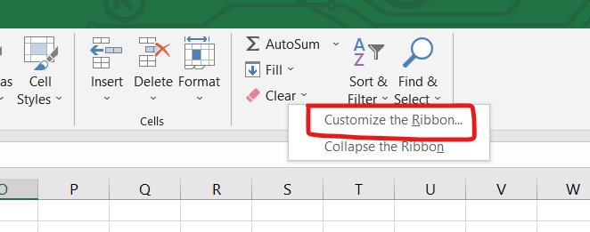

2. Click on new tab to create new tab and click on rename tab to give specific name.

In below example I have created new tab and renamed it to Ineuron.

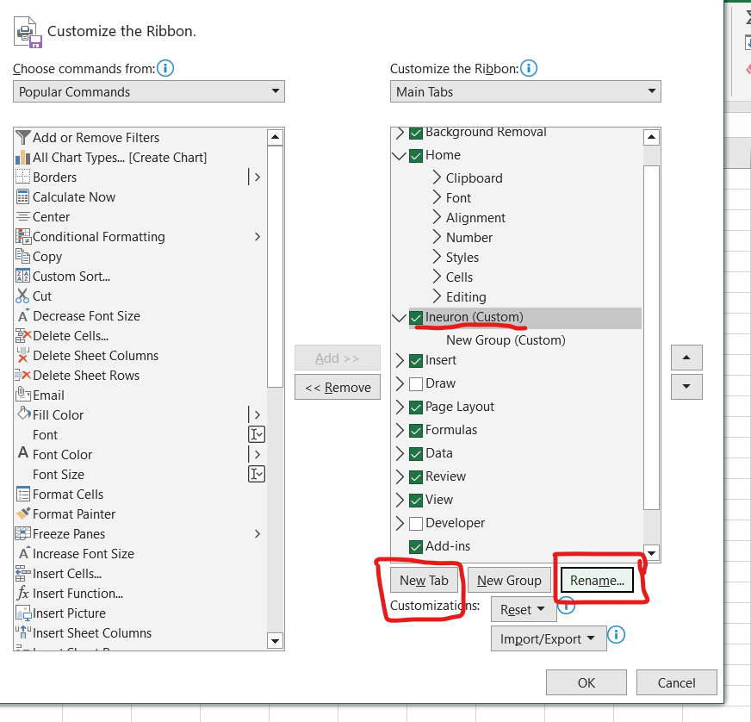

3. Check the below step 1 and 2 to create new group.

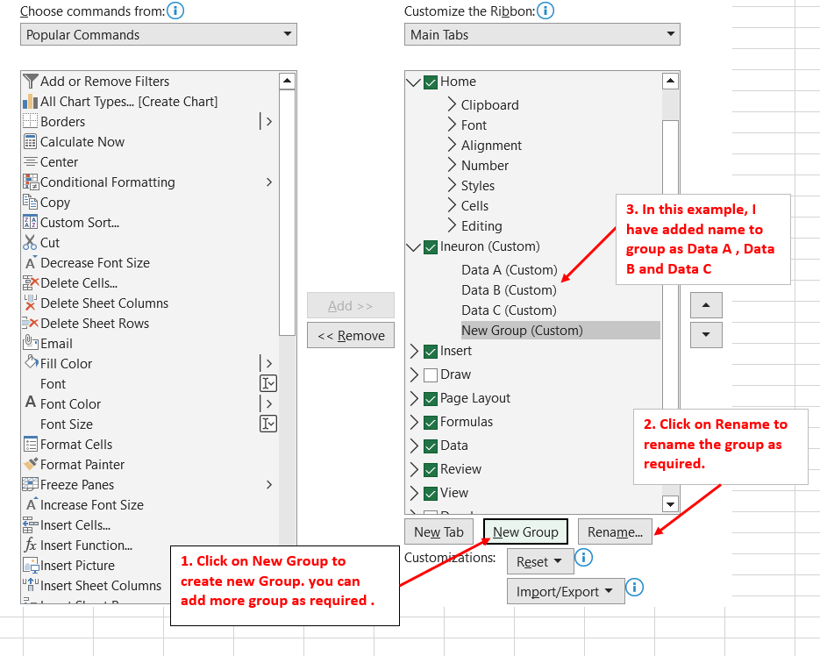

4. Followed below step to add commond in group and click on ok button.

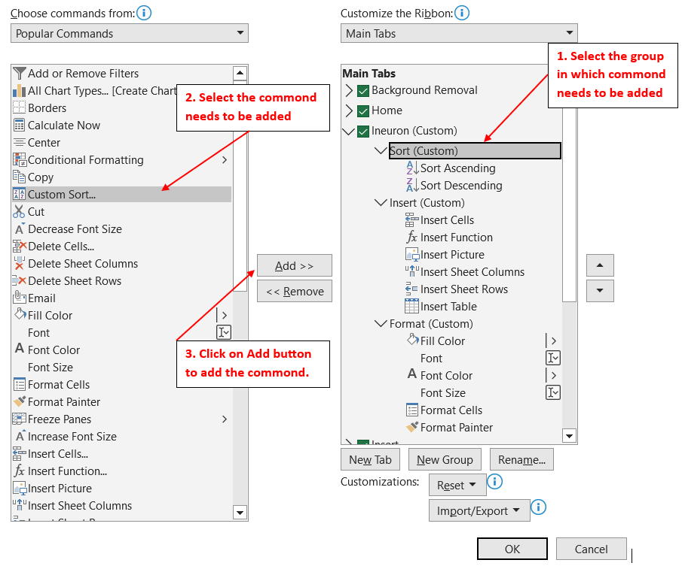

5. This way we can create the new tab in the ribbon.

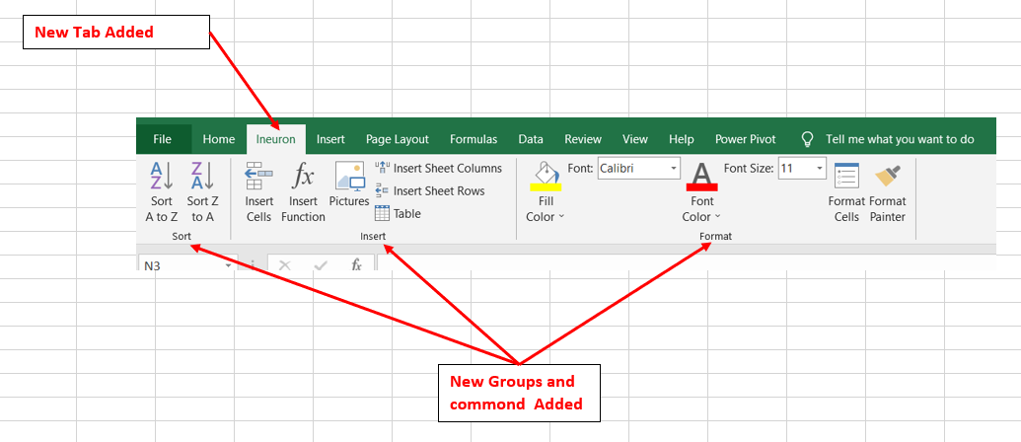

*4. Make a list of diﬀerent shortcut keys that are only connected to formatting with their functions.*

Keyboard shortcuts for formatting cells

|  |  |
| --- | --- |
| **To do this** | **Press** |
| Open the **Format Cells** dialog box. | Ctrl+1 |
| Format fonts in the **Format Cells** dialog box. | Ctrl+Shift+F or Ctrl+Shift+P |
| Insert a note.  Open and edit a cell note. | Shift+F2  Shift+F2 |
| Insert a threaded comment.  Open and reply to a threaded comment. | Ctrl+Shift+F2  Ctrl+Shift+F2 |
| Switch between displaying cell values or formulas in the worksheet. | Ctrl+Grave accent (`) |
| Copy a formula from the cell above the active cell into the cell or the formula bar. | Ctrl+Apostrophe (') |
| Move the selected cells. | Ctrl+X |
| Copy the selected cells. | Ctrl+C |
| Paste content at the insertion point, replacing any selection. | Ctrl+V |
| Open the **Paste Special** dialog box. | Ctrl+Alt+V |
| Italicize text or remove italic formatting. | Ctrl+I or Ctrl+3 |
| Bold text or remove bold formatting. | Ctrl+B or Ctrl+2 |
| Underline text or remove underline. | Ctrl+U or Ctrl+4 |
| Apply or remove strikethrough formatting. | Ctrl+5 |
| Switch between hiding objects, displaying objects, and displaying placeholders for objects. | Ctrl+6 |
| Apply an outline border to the selected cells. | Ctrl+Shift+Ampersand sign (&) |
| Remove the outline border from the selected cells. | Ctrl+Shift+Underscore (_) |
| Display or hide the outline symbols. | Ctrl+8 |
| Use the **Fill Down** command to copy the contents and format of the topmost cell of a selected range into the cells below. | Ctrl+D |
| Apply the **General**number format. | Ctrl+Shift+Tilde sign (~) |
| Apply the **Currency**format with two decimal places (negative numbers in parentheses). | Ctrl+Shift+Dollar sign ($) |
| Apply the **Percentage**format with no decimal places. | Ctrl+Shift+Percent sign (%) |
| Apply the **Scientific**number format with two decimal places. | Ctrl+Shift+Caret sign (^) |
| Apply the **Date**format with the day, month, and year. | Ctrl+Shift+Number sign (#) |
| Apply the **Time** format with the hour and minute, and AM or PM. | Ctrl+Shift+At sign (@) |
| Apply the **Number**format with two decimal places, thousands separator, and minus sign (-) for negative values. | Ctrl+Shift+Exclamation point (!) |
| Open the **Insert hyperlink** dialog box. | Ctrl+K |
| Check spelling in the active worksheet or selected range. | F7 |
| Display the **Quick Analysis** options for selected cells that contain data. | Ctrl+Q |
| Display the **Create Table** dialog box. | Ctrl+L or Ctrl+T |
| Open the **Workbook Statistics**dialog box. | Ctrl+Shift+G |

*5. What distinguishes Excel from other analytical tools?*

1. Microsoft Excel is best for arranging large sets of data into organized tables. The level of organization makes it easier to digest and analyze data.
2. You can plug in your data to create Data Visualizations like graphs and present & discuss your data better with C-Suite.
3. Excel streamlines your calculations. This way, you don’t have to worry about your output parameters when your input has changed. The software is intelligent enough to rework the calculations.
4. Excel is available on all leading platforms: Windows, Mac, Android, and iOS; on the web, and offline both.
5. Excel comes with a range of in-built functions that make accounting, math, statistics, logic, and database calculations easy.

*6. Create a table and add a custom header and footer to your table.*

1. Click the worksheet where you want to add or change headers or footers.

2. On the Insert tab, in the Text group, click Header & Footer. Excel displays the worksheet in Page Layout view.

3. To add or edit a header or footer, click the left, center, or right header or footer text box at the top or the bottom of the worksheet page (under Header, or above Footer).

4. Type the new header or footer text. (see below)

***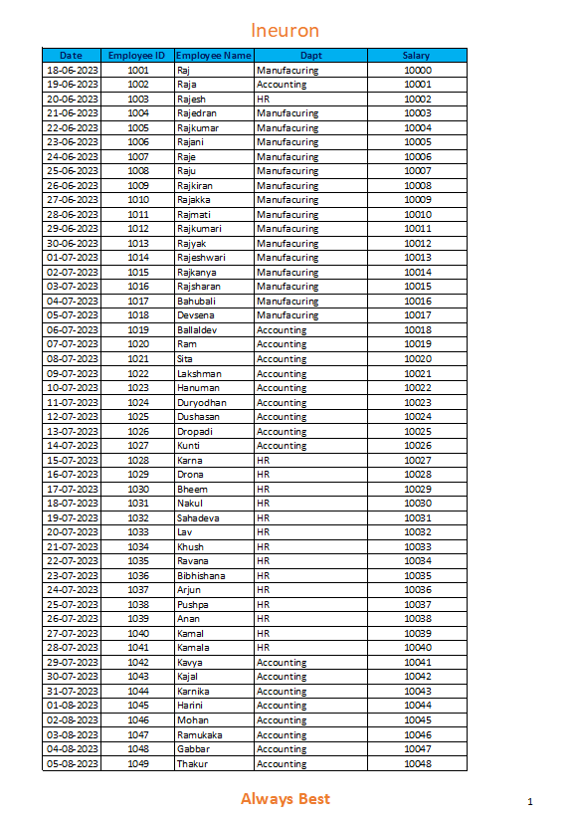*Header**

**Footer**